# Christopher Hyde

# Southern New Hampshire University: IT-385

# Final Project

# Gmail™ Training Manual

# 8/19/2018



**Introduction**

For the 3rd quarter of 2018, XYZ Company plans to transition from using Microsoft Outlook ™ as it’s corporate email system over to Google’s Gmail™. With Google being the most popular and widely recognized search engine, it only makes sense to make this move. In preparation for this rollout, a training manual has been developed to assist employees with this transition and make it as seamless as possible. Since all users have varying technical abilities and computer knowledge, a simpler approach has been taken in the production of this manual.

**Product Description and Key Features**

They are several key advantages to the browser-based format of Gmail.

* **Storage**: As Gmail is web-based it offers a much larger storage capacity over Outlook; up to 15GB of storage per user.
* **Security**: Gmail has added more security features this year including Confidential Mode, Two-Factor Authentication, and expiration dates on emails. (Satter, 2018)
* **Searching:** Gmail has some powerful search features such as searching by sender, subject or keyword or within the current email thread. Incoming emails can also be filtered to be sent to various labelled folders so users can personalize how their mail is organized.
* **Customization & Layout**: Gmail offer a much more attractive layout than Outlook - one that can be tailored to the user with various panels and color schemes and wallpapers.
* **Google Tool Integration**: Gmail can integrate its content with other Google apps such as Google Drive™, Google Maps™, Google Calendar™, Google Translate™ and of course, Google Search™.

**User Needs**

This manual is written in such a way that it assumes the intended audience has at least some basic computer skills and may not already be familiar with Gmail. The purpose of this training manual is not necessarily make every user an expert in Gmail, but to provide basic instructions on how to operate the mail program. So, while the content may be very easy for the expert user to grasp, it is more geared towards novice users. It will more or less be a self-study manual with different modules. Each self-contained Module will include a lesson that briefly and simply explains the task and walks the user through it using various examples.

**Manual Organization**

This scope of this manual will be a comprehensive guide to educate the user on the basic functions of Gmail and how it functions in their day-to-day workload. Topics included are:

* *Getting Started*
* *Composing and Sending Email*
* *Managing your Inbox*
* *Email Attachments*
* *Managing Contacts*
* *Managing Calendars*

(Gmail, 2018)

**Format and Delivery**

This manual will use is a combination of step-by-step text instructions as well as screenshots like the example below. This will assist users to both read and see what the next step would be. For example:

Step 1: Go to Gmail.com and “Create an Account”

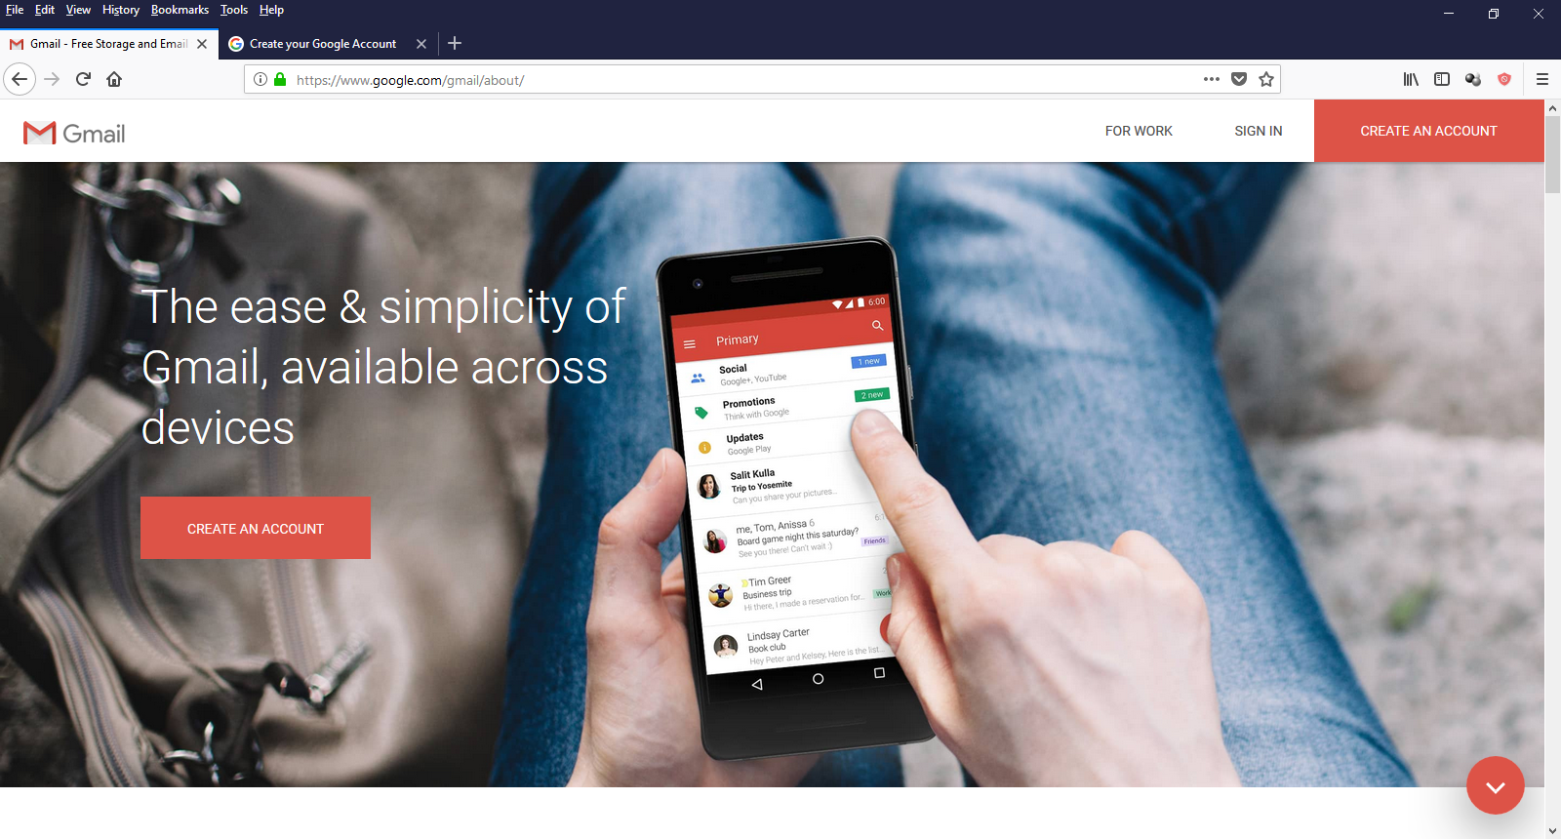

(Gmail, 2018)

Step 2: Enter the necessary information…then click “Next”

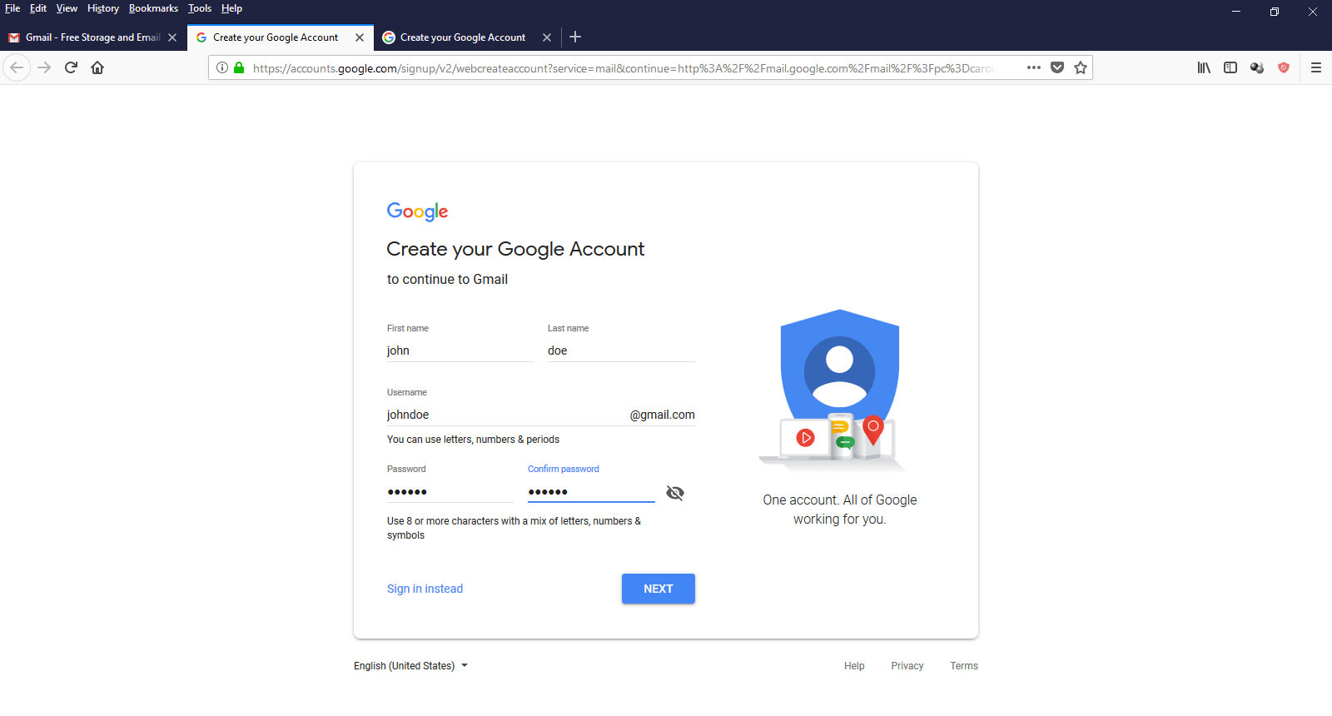

(Gmail, 2018)

This guide will cover all of the necessary steps to get this user acquainted with and comfortable using Gmail’s main features.

**Basic Training: Purpose & Format**

The purpose of this section of the training manual is to teach the user basic functions of Gmail. Transitioning from Outlook to Gmail will not only increase productivity and efficiency, it will also be beneficial for budgetary reasons as well. The step-by step lessons will demonstrate how easy Gmail really is. By the end of the training, users will be acquainted with Gmail and know how to swiftly and effectively navigate through the various screens. They will be able to send email, add attachments, manage their inbox, sync their calendar, and more. Eventually, it will become second nature to the user.

The format will follow a series of modules outlining the various aspects of Gmail using screenshots and illustrations to guide the user along. In the Basic Training segment, we will go over the processes of Creating an Account, Logging In, Sending an email and Adding Attachments.

**Basic Training: Gmail Operation**

*Module 1: Getting Started*

**Creating an Account (First time use)**

Step 1: Open your web browser and go to [www.gmail.com](http://www.gmail.com)

Step 2: Click “Create an Account”



(Gmail.com, 2018)

Step 3: Enter the necessary information…then click “Next” 



(Gmail.com, 2018)

**Signing in (after Creating an Account)**

Step 1: At the Login screen, enter your Email address and click the “Next”. 

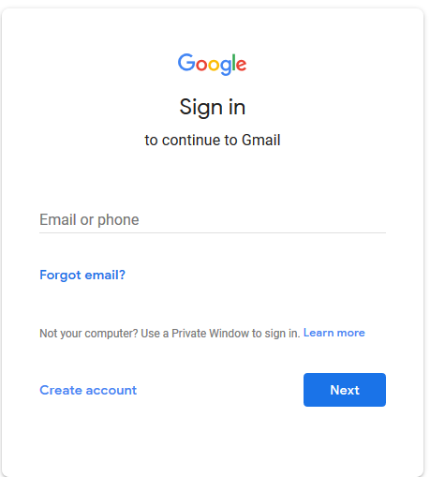

Step 2: Enter your Password and choose “Next” 

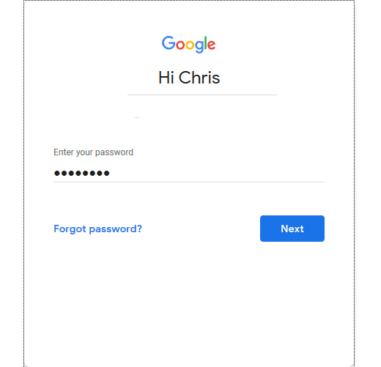

*Module 2: Composing and Sending Email*

**Sending an Email**

Step 1: To start an email click “Compose” 

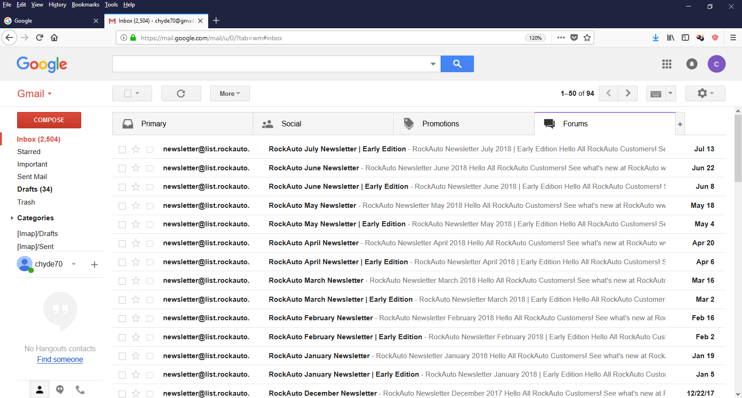”

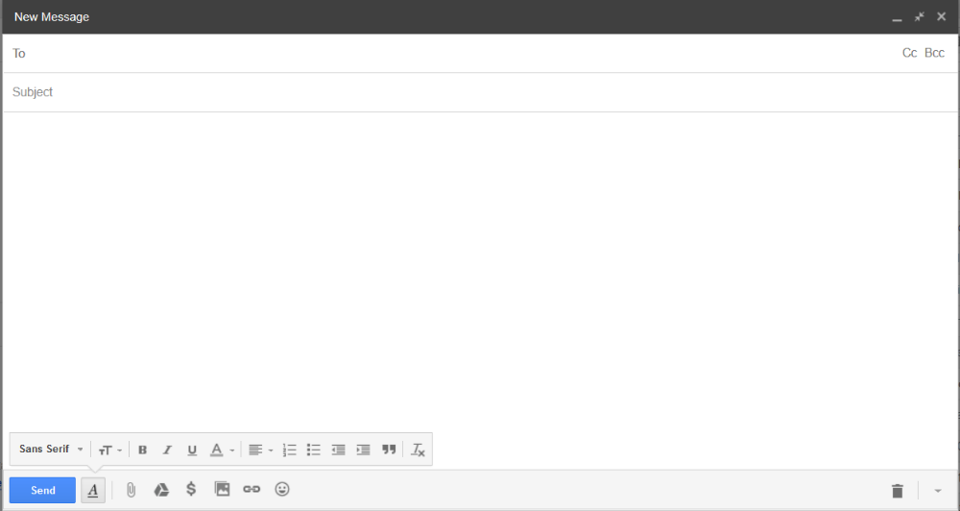The following screen will appear….

Step 2: Click on the space next to the “To” field and enter the email address of the primary intended recipient(s).

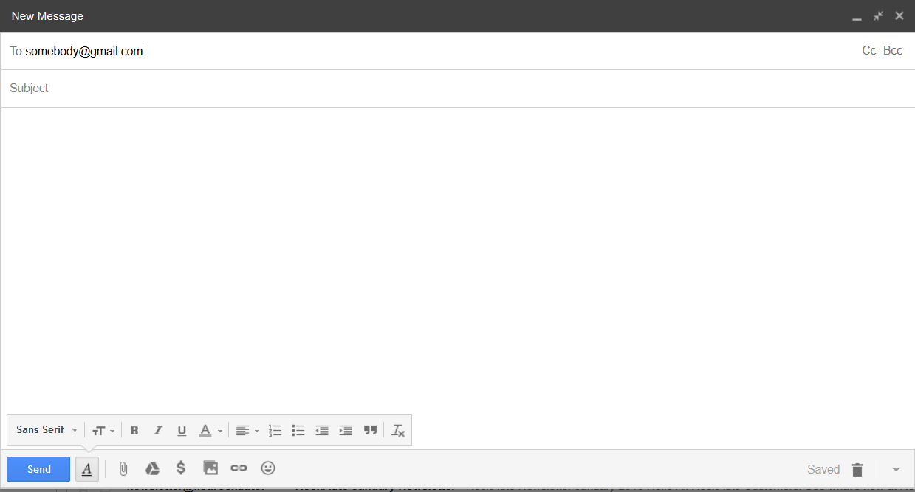

Step 3: To include others in the email who may be interested but not required to respond, click the “Cc:” button 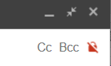 in the upper right-hand corner and enter their email address.

Step 4: If you want to select multiple recipients from your Personal Contact List (which we will go over later in the manual), click on the word “To” and the following screen will appear…

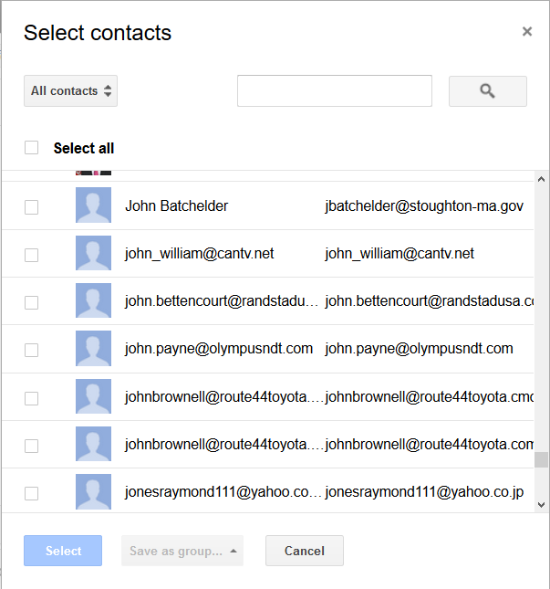

Step 5: You can choose to select which Contact list to choose from (i.e. Friends, Family) or you can search by Keyword.

Step 6: Click the box next to the person(s) you wish to send the email to and click “Select”.

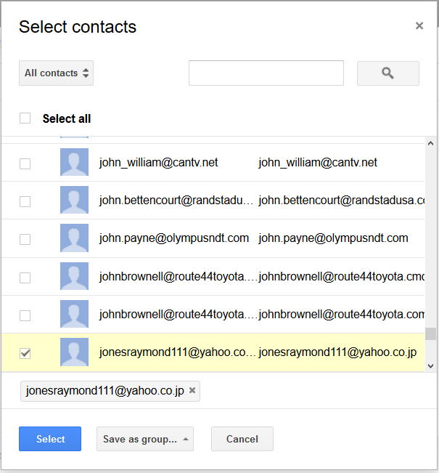

The selected recipient(s) will appear in the “To” box.

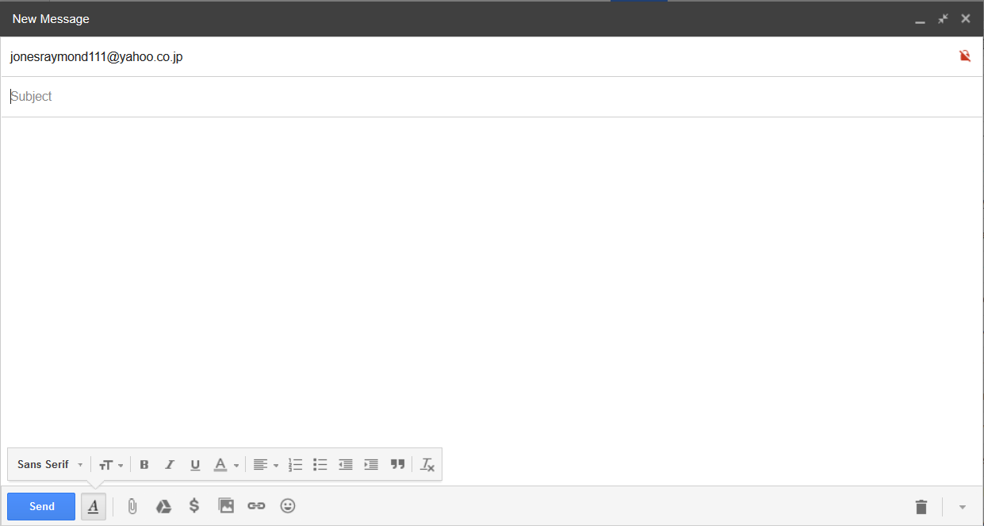

Step 7: Add the Subject of the email by clicking “Subject” 



The Subject you typed will appear in the box…

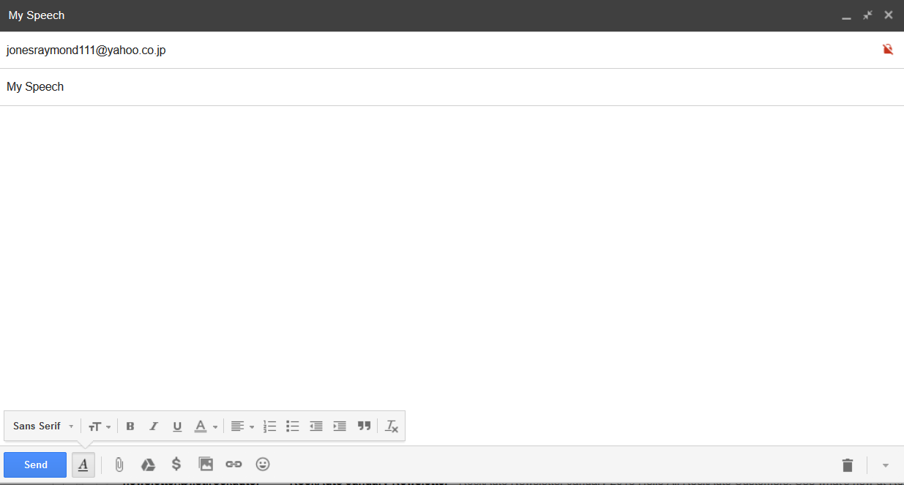

Step 8: Add the body of the email in the large blank space.

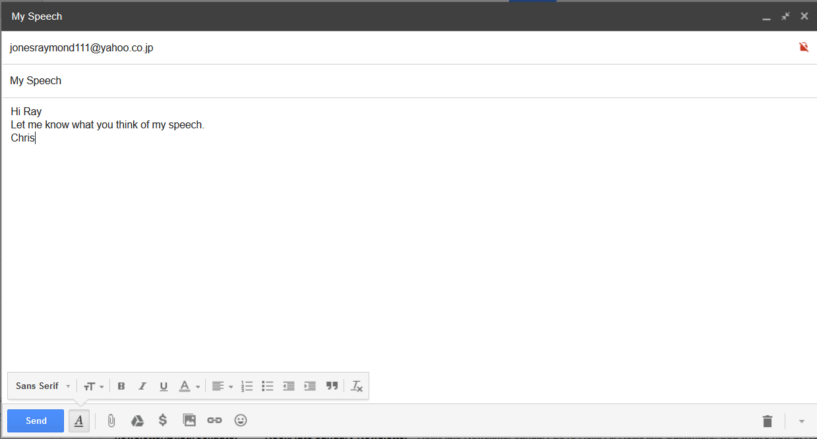

*Module 3: Email Attachments*

Step 1: To embed a picture in the email, click this icon… and proceed to Step 3.

Step 2:To add a file click on the paperclip icon. 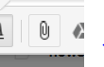

Step 3: Find the file you wish to attach and clock “Open”.

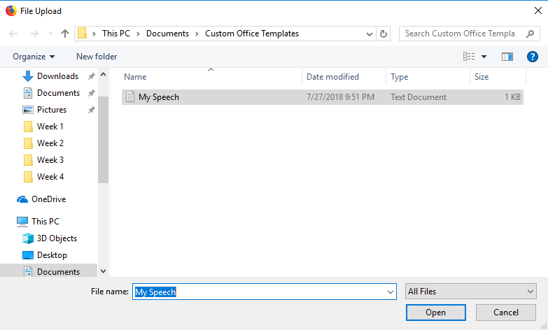

As you can see that the file has been added to the email…

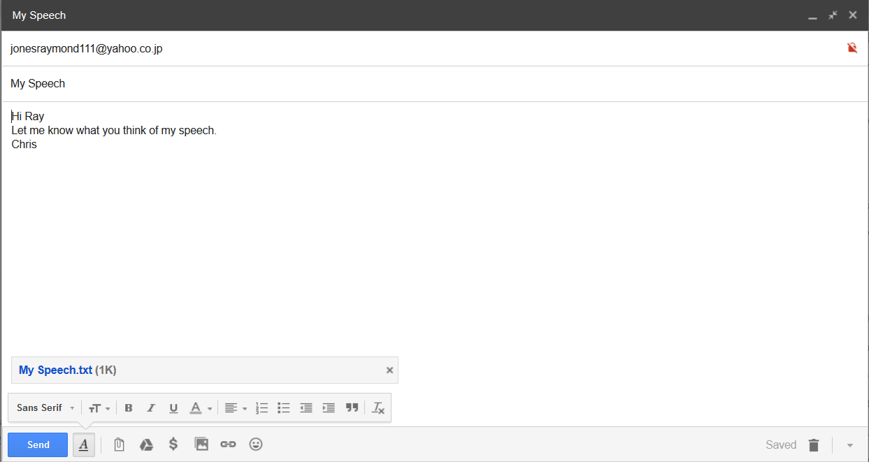

Step 4: To add a link to a website into your email, click this icon…

Step 5: Enter the website address and add a comment. The click “OK”.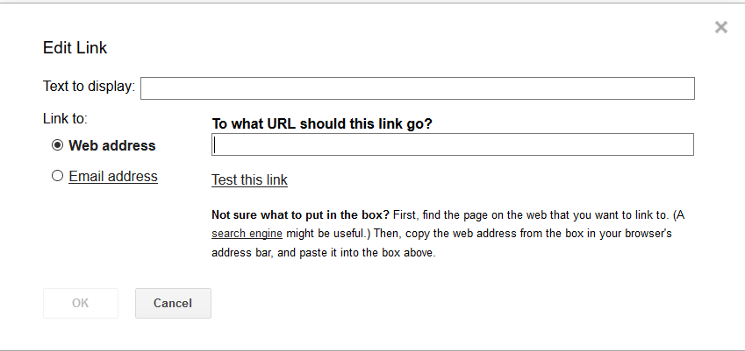

Step 6: To delete the email and start over , click the trash can 

Step 7: Finally, once you are satisfied with your email, click “Send”  to deliver it.

Step 8: Success…good work!

*This completes the basic training section.*

**Intermediate Training: Purpose & Format**

The purpose of this portion of the training manual is to teach the user the intermediate functions of Gmail. The additional features enhance the experience of Gmail and allow departments to be even more productive from a business standpoint. The step-by step lessons will demonstrate how easy Gmail really is. By the end of this segment of the training, users will be acquainted with the more in-depth features of Gmail beyond just the basics.

As in Section One, the format will follow a series of modules outlining the various aspects of Gmail using screenshots and illustrations to guide the user along. In the Intermediate Training segment, we will cover topics such as using filters to manage your inbox; adding and sorting contacts, and syncing your calendar with Gmail Invites™.

**Intermediate Training: Gmail Operation**

*Module 1: Managing Your Inbox*

**Creating a New Label**

Step 1: On the left side Gmail panel, scroll down to “Labels” and click “Create New Label”

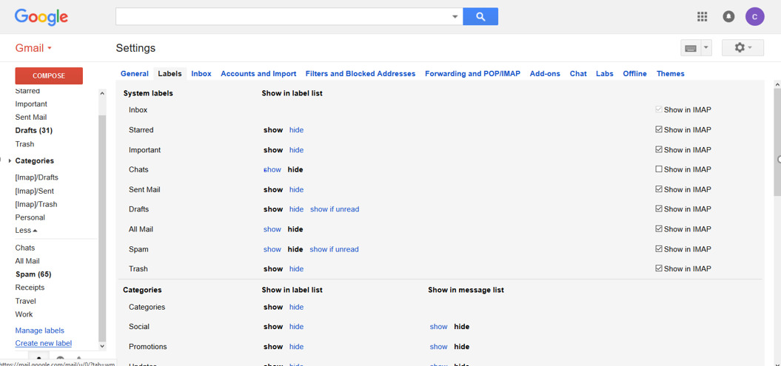

Step 2: Enter a Name for your label as well as the parent label (if any) and click “Create”

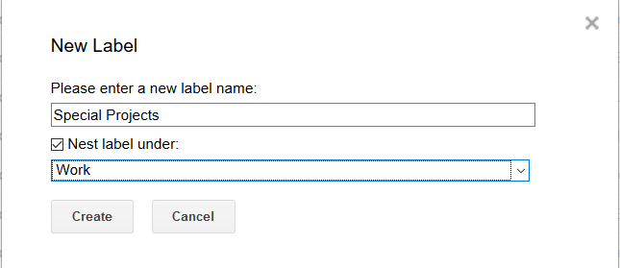

…You new label will now appear on the left panel.

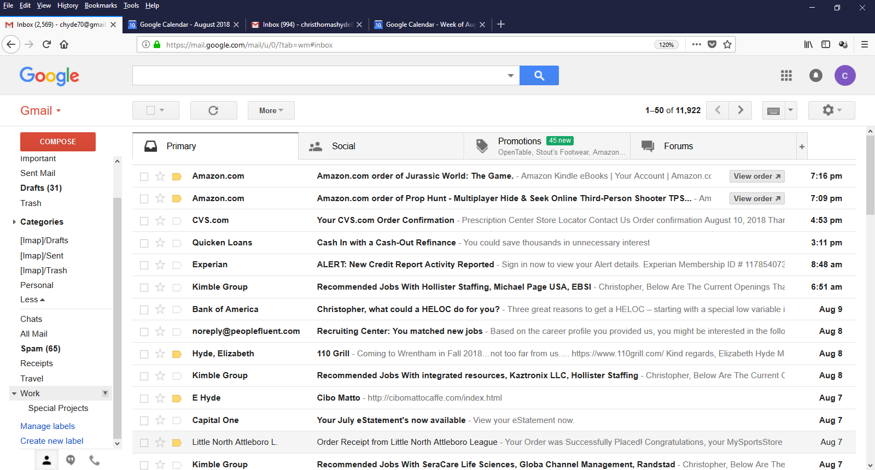

**Applying a Label**

Step 1: Click the checkbox next to the emails you wish to label…

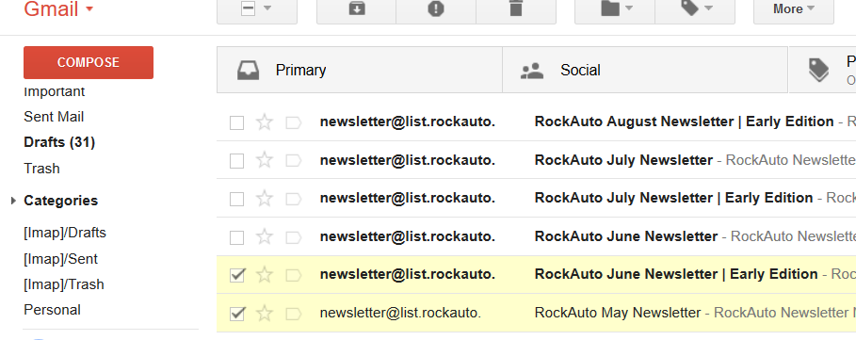

Step 2: Click the Labels icon. 

Step 3: Check the box of the label you wish to apply to those emails and click Apply.

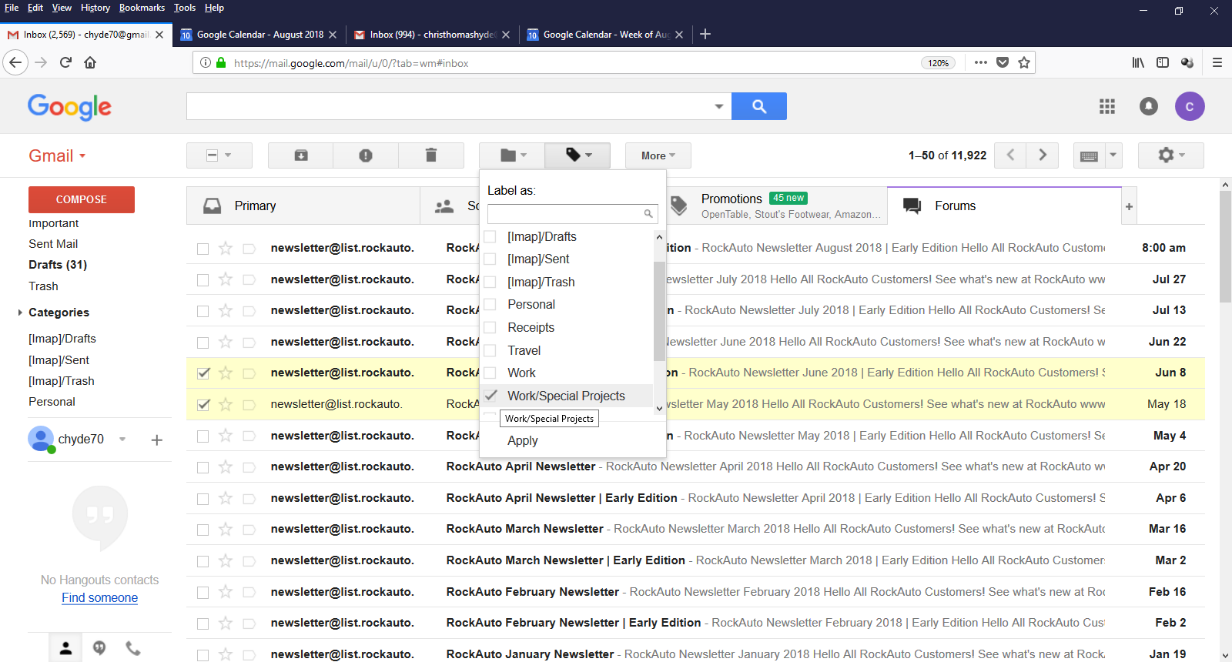

…The emails you checked will now appear under that label

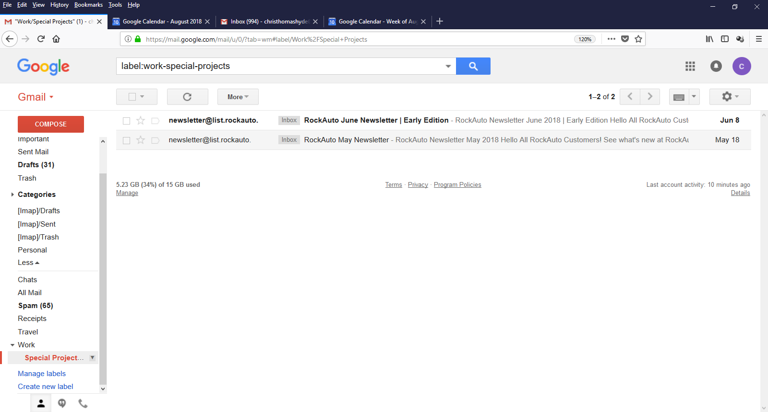

**Filtering (Search)**

Step 1: To add a Filter, enter the keyword in the search window of Gmail then click the magnifying glass. In this example we will try the name “Vivian”.



Step 2: To apply the filter to a specific Label, click on the pull-down.



The following screen will appear…

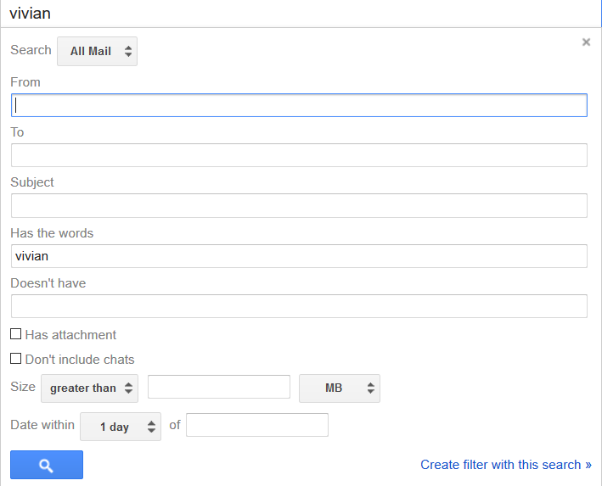

Step 3: Select the Label using the button below…



Step 4: Click the magnifying glass. 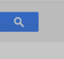

**Filtering (Incoming Email)**

You can also filter incoming email and instruct Gmail to do things like delete the email, forward it, move it to a specific label, and more. In this example, we will mark all emails with the word “Urgent “in it as Important.

Step 1: Follow Steps 1 & 2 under Filtering.

Step 2: Enter “urgent” in the “Has the words” field.

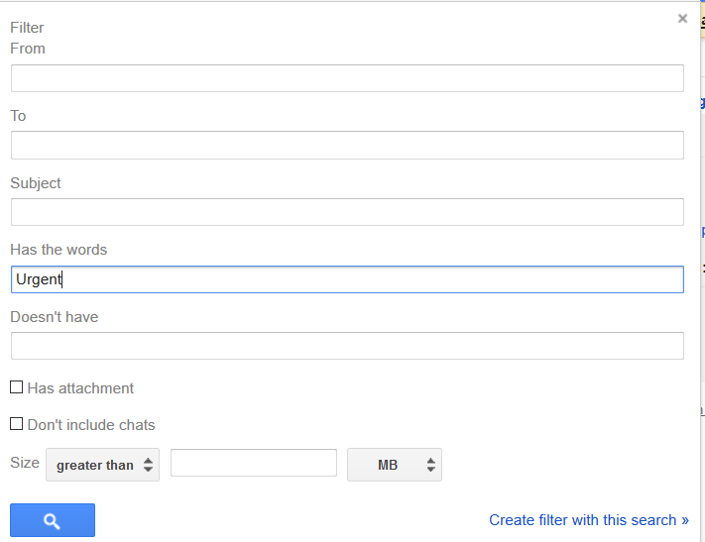

Step 3: Click on “Create Filter with this search”



The following screen will appear:

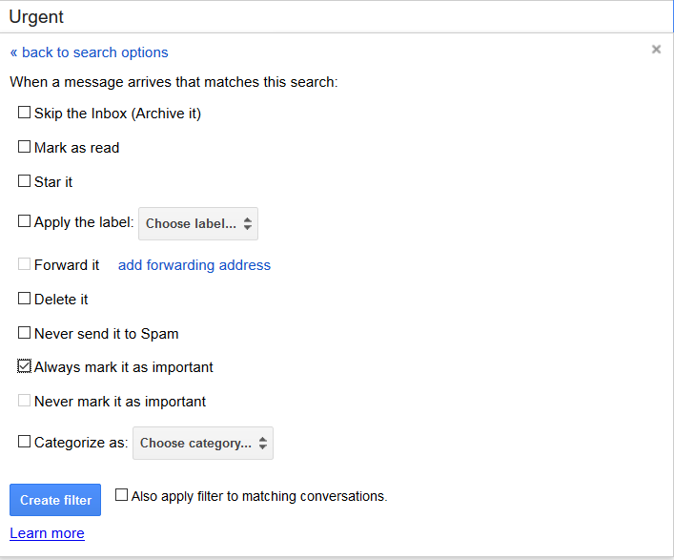

Step 4: Check the box “Always mark as important” and click “Create filter”

Step 5: Go to Settings and click on the Filters and Blocked Addresses tab.

Step 6: Check the box next to the filter you just created.

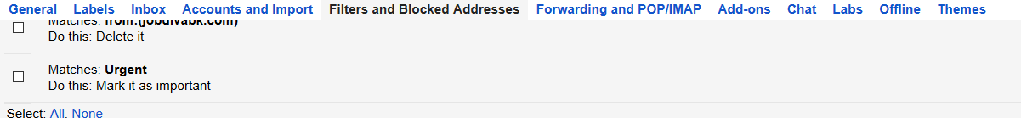

Now, moving forward, all emails with the word “urgent” will be automatically marked as Important.

*Module 2: Managing Contacts*

**Creating a Contact**

Step 1: Go to Contacts in your Google Apps

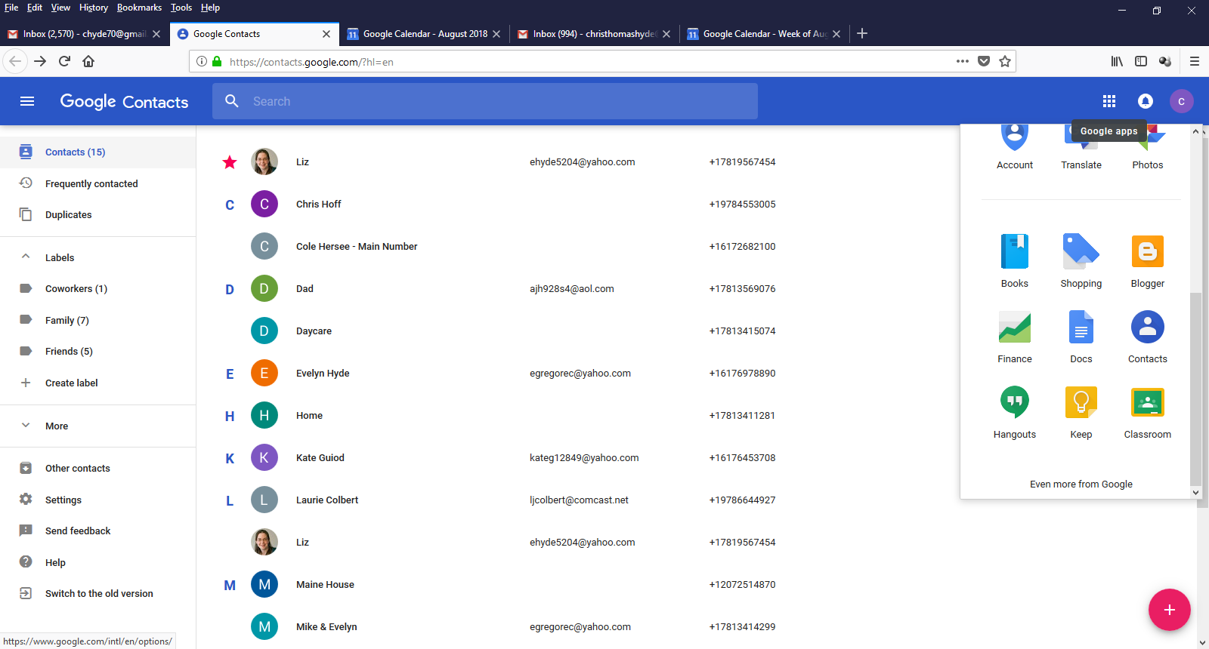

Step 2: Click Add in the bottom right corner.

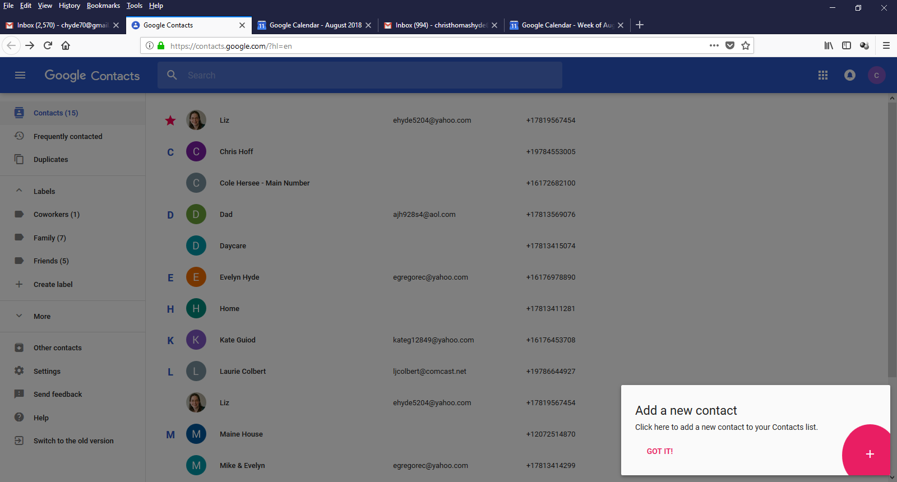

Step 3: Enter the Necessary information and click Save.

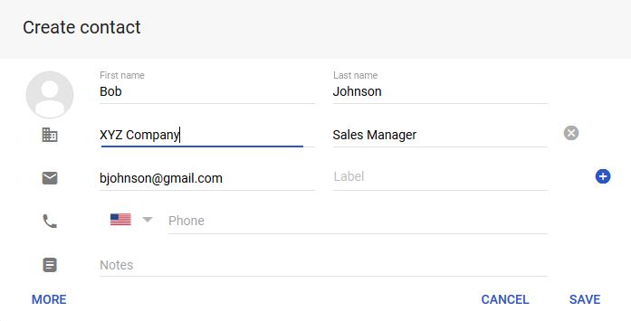

The new contact will be created as shown below…

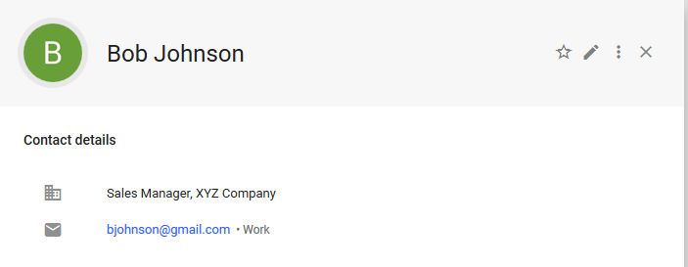

**Creating a Group**

Step 1: Go to Google Contacts and select “Create Label”

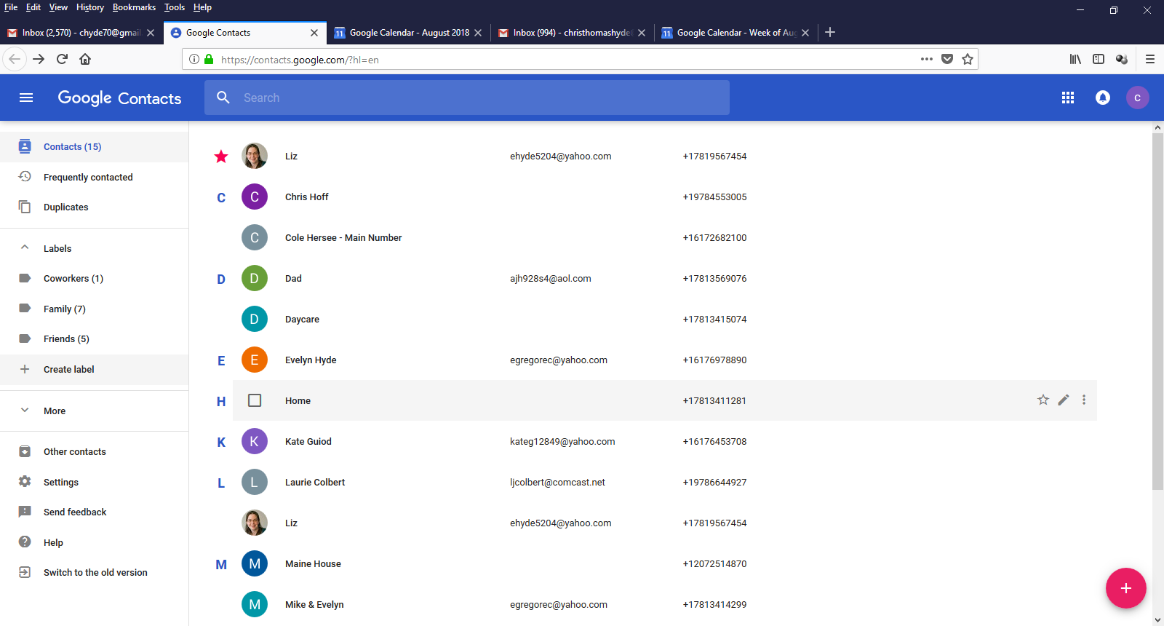

Step 2: Give your Label a name and click ”Ok”. In this instance we will choose “Work”.

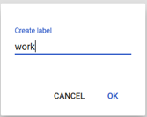

…”Work” has now been added as a Group.

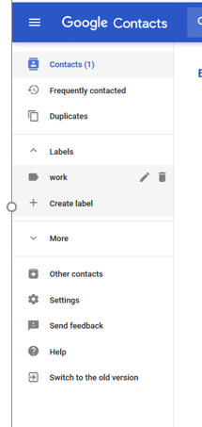

**Deleting a Contact**

Step 1: Go to Contacts from your Google Apps

Step 2: Click the check box next to the Contact you wish to delete.

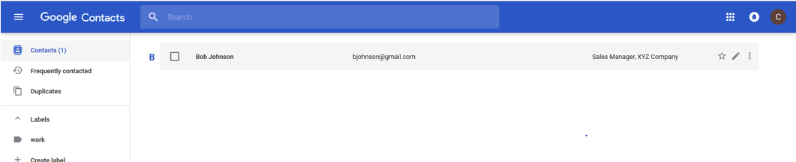

The contact will be displayed…

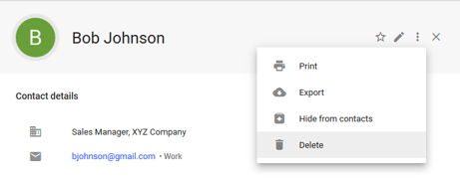

Step 3: Click Delete to remove the contact.

*Module 3: Managing Your Calendar*

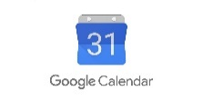

**Creating a Calendar Event**

Step 1: Go to Google Calendar

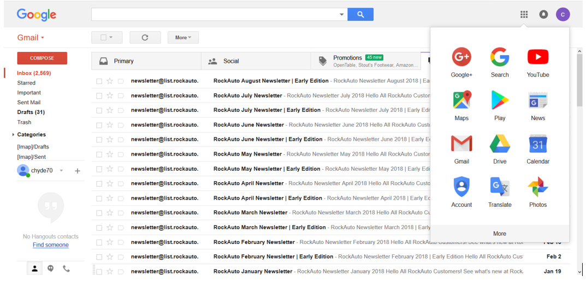

Step 2: Select the date you want the event to occur on. We will choose Aug 13th.

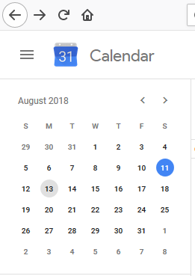

Step 3: Give your meeting a title, select the timeframe, and click Save.

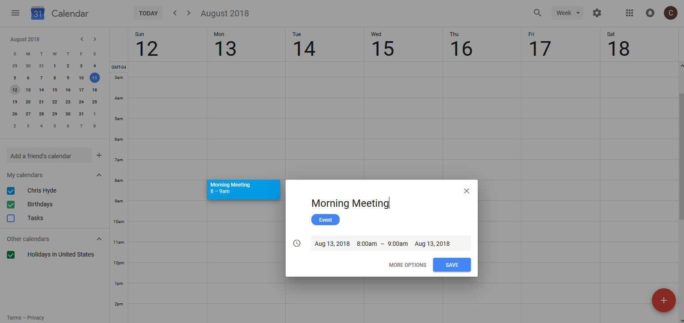

…You will see that the Morning Meeting has been added to your calendar on Aug 13th at 8am.

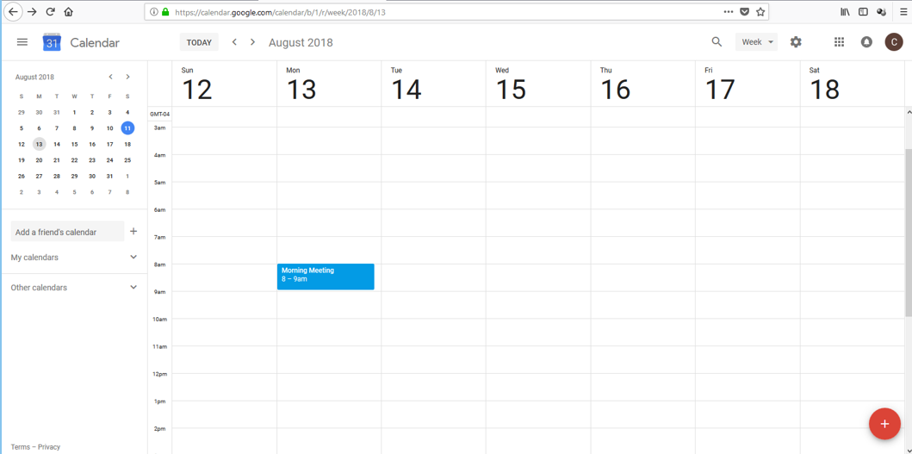

**Inviting Guests to an Event**

Step 1: Select the Event from your calendar.

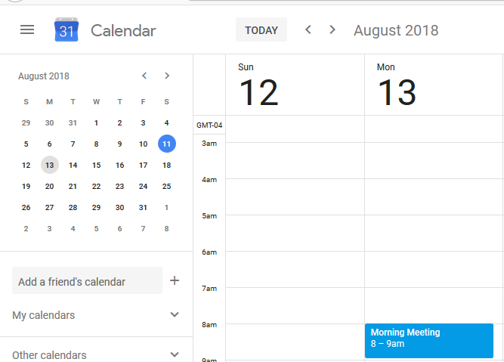

The event will be displayed…

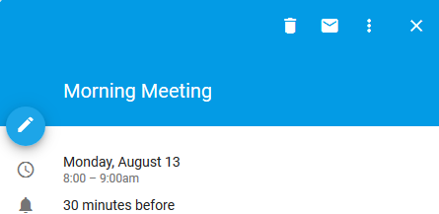

Step 2: Click the Edit Event button  to see all of the event attributes.

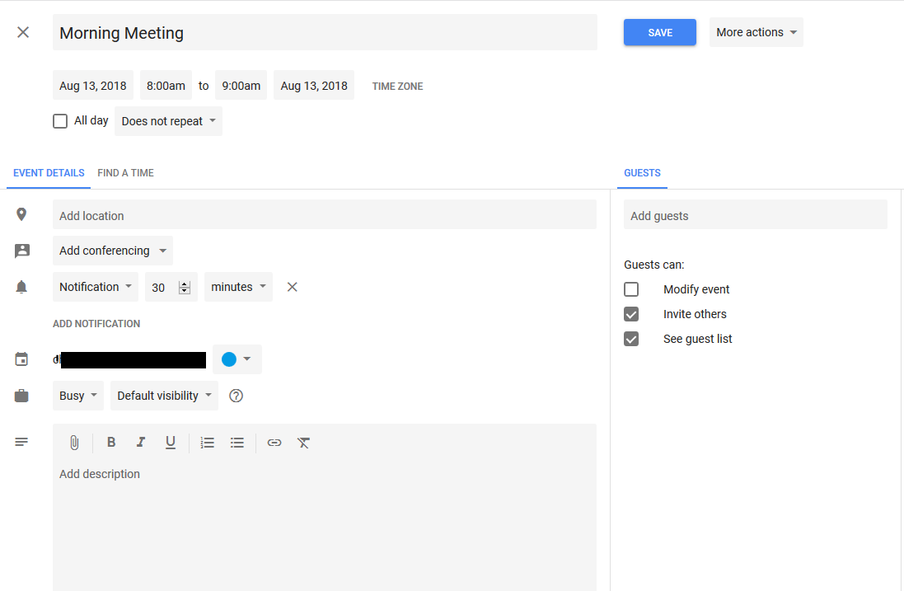

Step 3: Click on Add guests and click on the person(s) you wish to add from the drop-down list. You can also type in their name here to perform a search of all of your saved Contacts or Groups.

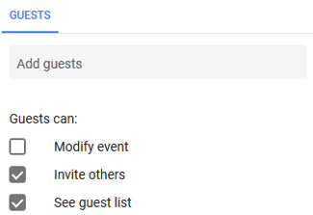

Step 4: Click Save.

Step 5. Click the “More actions” pull-down menu and choose “Publish Event”

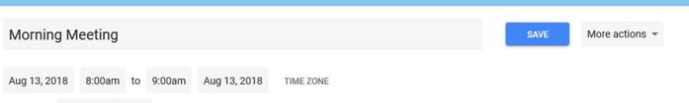

…The invitees will now receive an email notifying them of the meeting. They can then reply with a “Yes” or “No” regarding their ability to attend the meeting. It will then be added to their own calendar.

**Sharing Your Calendar**

Step 1: Go to Google Calendars

Step 2: Hover your curser of the calendar under ”My Calendars” that you wish to share. Click “Options”

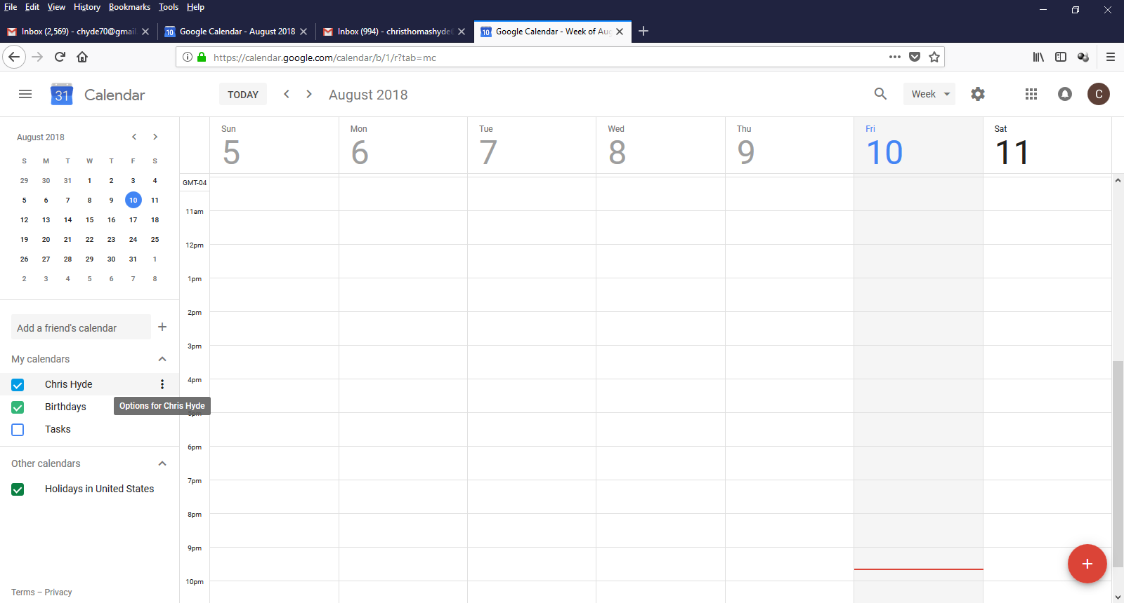

Step 3: Click on “Settings and Sharing”

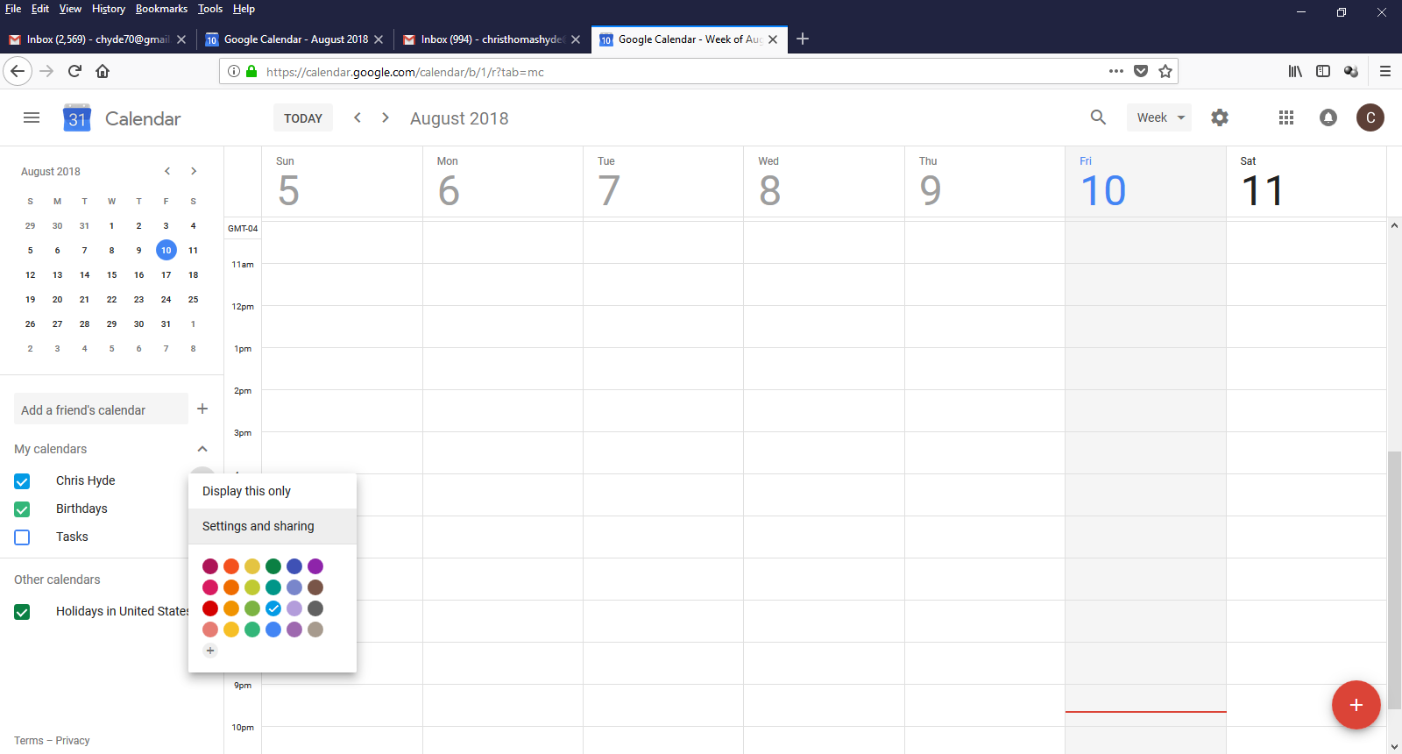

Step 4: Click and select the contacts or groups you wish to share your calendar with from the drop-down menu. Then click .

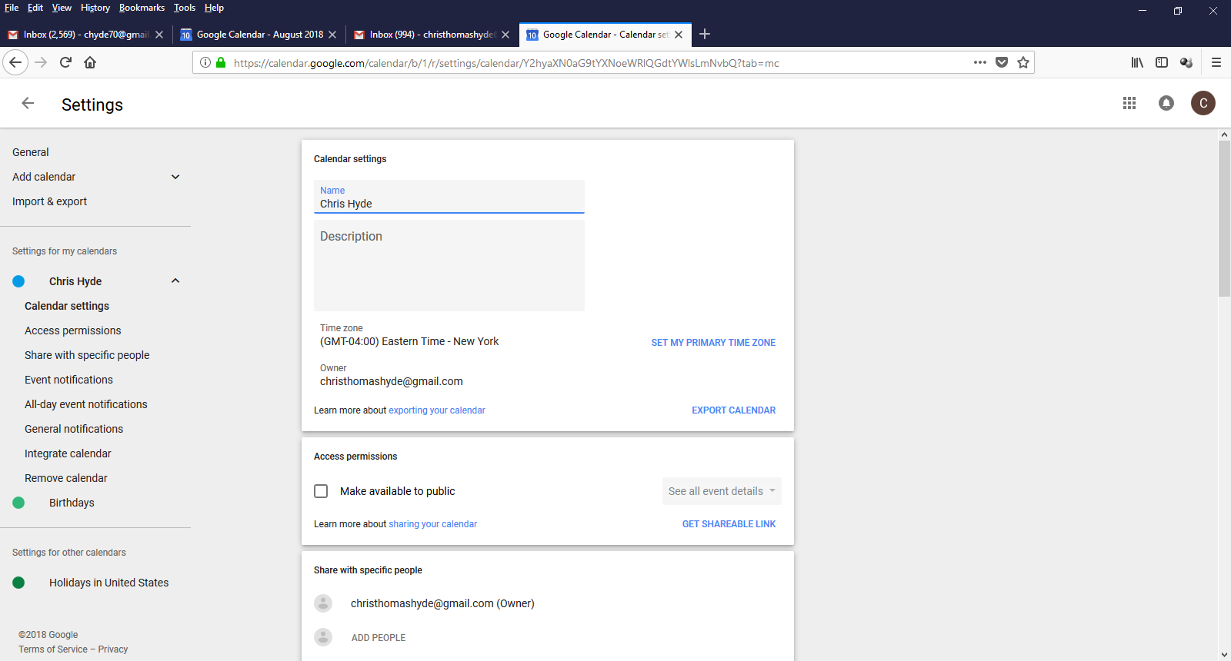

…Those co-workers will now be able to see your calendar and know when you are available.

*This completes the Intermediate Training Segment.*

**Summary**

With all the features that Gmail has to offer, Google has been innovative in keeping up with the latest email trends and has the most flexible, intuitive and robust email programs out there. It is one that can be accessed by any device wherever you are. Hopefully, now that you have completed the training you have a better understanding of this amazing application. While this manual mainly showcased the primary features, there is so much more that Gmail has to offer. Be sure and check out the videos below for additional information.

**Additional Videos**

# Gmail Basics Tutorial Plus Advanced Tips & Tricks 2016

<https://www.youtube.com/watch?v=9JiOOda0n3w&t=171s>

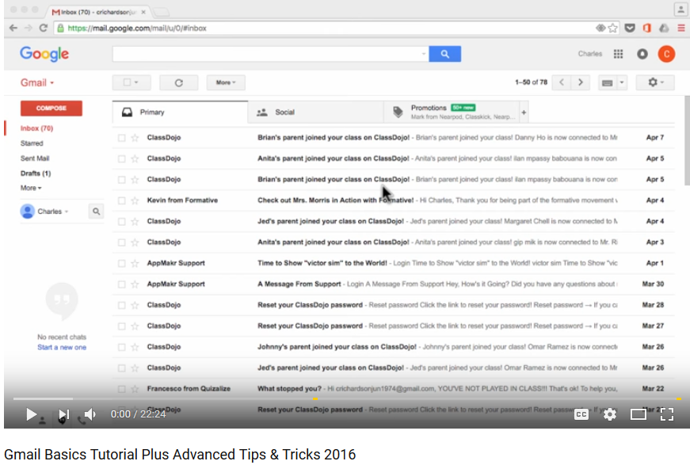

The New Google Calendar 2018 Tutorial

<https://www.youtube.com/watch?v=TsgBNi8YEs0&t=12s>

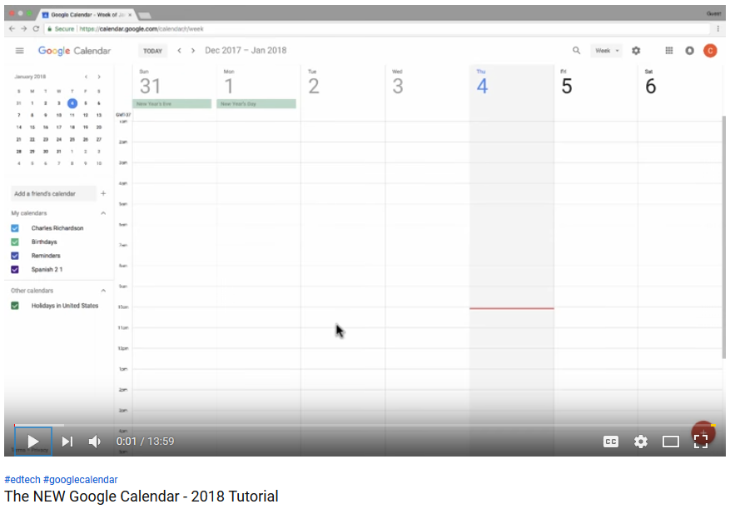

**Legal Disclaimer**

This manual is produced and owned by XYZ Company. It is intended for internal use only. Due to copyright purposes, no duplication is allowed without consent of said company. By no means is this an official training manual set forth by Google or its affiliates. Since this manual cannot cover every possible aspect of the program or address every issue, there is no guarantee than the user will have a complete knowledge of the program. XYZ Company denies any responsibility for any misuse, loss of information, or any illegal activity involvement as a result of the training.

**References**

Smith, Worthington, Jefferson (2010). Audience and Purpose. *Technical Writing for Success.* Retrieved from https://mbsdirect.vitalsource.com/#/books/111178678X/-cfi/11!/4/4@0.00:0.00

# Satter, M (2018, April 25) Here's all the security features in the new Gmail. *Cyberscoop.* Retrieved from <https://www.cyberscoop.com/gmail-security-features-confidential-mode-expiration-dates/>

Google (2018). Get Started With Gmail. *G Suite Learning Center.* Retrieved from <https://gsuite.google.com/learning-center/products/gmail/get-started/#!/>

Google (2018). About Gmail. *Gmail.* Retrieved from <https://www.google.com/gmail/about/>

Google (2018). Get Started With Contacts. *G Suite Learning Center.* Retrieved from <https://gsuite.google.com/learning-center/products/gmail/get-started/#!/>

Google (2018). Optimize Your Inbox. *G Suite Learning Center.* Retrieved from <https://gsuite.google.com/learning-center/products/gmail/get-started/#!/>

Google (2018). [Gmail Logo]. Image retrieved from <https://www.google.com/gmail/about/>

Google (2018). [Google Calendar Logo]. Image retrieved from <https://www.google.com/gmail/-about/>.

[Technology for Teachers and Students](https://www.youtube.com/channel/UCYUPLUCkMiUgiyVuluCc7tQ). (2016, April 21). Gmail Basics Tutorial Plus Advanced Tips & Tricks 2016. Retrieved from <https://www.youtube.com/watch?v=9JiOOda0n3w&t=171s>

[Technology for Teachers and Students](https://www.youtube.com/channel/UCYUPLUCkMiUgiyVuluCc7tQ). (2018, Jan 8). The New Google Calendar 2018 Tutorial. Retrieved from <https://www.youtube.com/watch?v=TsgBNi8YEs0&t=12s>